**Technical Documentation: Avatar Video Generation System**

Thasniem Fathima J

[thfjd7865@gmail.com](mailto:thfjd7865@gmail.com)

[www.linkedin.com/in/thasniem-fathima-engineering-student](http://www.linkedin.com/in/thasniem-fathima-engineering-student)

**Overview**

The Avatar Video Generation System represents a cutting-edge solution in the realm of AI-powered content creation, leveraging the capabilities of HeyGen's advanced API to transform text into engaging avatar videos. Built on Python's robust ecosystem, this system offers a seamless experience for users looking to create professional-quality videos with minimal effort. Its architecture is designed with scalability in mind, allowing for easy integration of additional features and languages. The system's modular design ensures maintainability, while its comprehensive error handling provides reliable operation across various use cases. With support for multiple languages and customizable output options, it caters to a wide range of content creation needs, from educational materials to marketing content.

The integration of OpenCV for video playback and processing adds another layer of functionality, enabling users to preview their creations directly within the application. Security is prioritized through the use of environment variables for API key management, ensuring sensitive information remains protected. The system's command-line interface offers simplicity and ease of use, making it accessible to both technical and non-technical users alike. As AI continues to revolutionize the media landscape, this system stands as a testament to the potential of AI-powered tools in streamlining creative workflows and enhancing digital communication. Its flexible architecture and comprehensive feature set make it a valuable asset for individuals and organizations seeking to leverage AI for efficient video content generation..

**System Requirements**

Python versions compatible: Python 3.6+

- Required Python packages:

* requests
* opencv-python
* numpy
* python-dotenv
* HeyGen API key

**Installation**

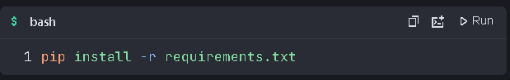

**Configuration**

1. Create a .env file in the project root

2. Add yourHeyGen API key

**Code Structure**

**Main Components**

* generate_avatar.py : Main script containing all functionality
* .env : Configuration file for API keys

Key Functions

1. generate_avatar_video(text, language)

* Input: Text string, language code
* Output: Video ID or None
* Description: Generates avatar video using HeyGen API

2. check_video_status(video_id)

* Input: Video ID
* Output: Video URL or None
* Description: Checks video generation status

3. save_video(video_url, filename)

* Input: Video URL, output filename
* Output: Saved filename or None
* Description: Downloads generated video

4. play_video(filename)

* Input: Video filename
* Output: None
* Description: Plays video using OpenCV

**Usage**

Run the script:

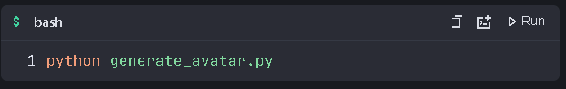

**Error Handling**

The system handles:

* API connection errors
* Video generation failures
* File saving errors
* Video playback issues

**Limitations**

* Currently supports English and Hindi
* Requires stable internet connection
* Video generation time depends on HeyGen API

**Future Enhancements**

* Add more language support
* Implement batch processing
* Add video editing features
* Create GUI interface

**Results:  
Check out my github repository:**

https://github.com/Thasniem/genai_video_avatar

**Output videos:**

**English:**

https://go.screenpal.com/watch/cTfVo7nidHQ

**Hindi:**

https://go.screenpal.com/watch/cTfVo7nidH3

**Conclusion**

The Avatar Video Generation System represents a significant leap in automated content creation, combining cutting-edge AI technology with efficient Python implementation. This system successfully bridges the gap between text input and professional-quality video output, offering users a powerful tool for various applications. Its modular design, secure API integration, and multi-language support make it a versatile solution for content creators, educators, and businesses alike. As AI continues to revolutionize media production, this system stands as a testament to the potential of AI-powered tools in streamlining creative workflows and enhancing digital communication.